A REPORT ON DIGITAL FORENSICS INVESTIGATION USING AUTOPSY ON THE disk image nps-2009-canon2-gen1.E01

BY NAKABIRI PENINA 23/BIT/BU/R/0003

1. INTRODUCTION
A forensic examination was conducted on the disk image nps-2009-canon2-gen1.E01 using Autopsy. The image was identified as a digital camera memory card, not a computer hard drive. Consequently, no web browsing artifacts, cookies, or downloads were present. Keyword searches for "password" and "confidential" yielded no results. File system analysis, deleted file recovery, and timeline analysis were performed as per standard procedures.
2.OBECTIVES
- To analyse the disk image using Autopsy
- To recover deleted files
- To identify suspicious and accessed files
- To examine web activity
- To perform keyword searches
- To reconstruct events using timeline analysis

3. METHODOLOGY
The investigation followed standard digital forensic procedures:
- Acquisition – Using the provided forensic image (E01 format)
- Preservation – Ensuring no modification of original evidence
- Analysis – Using Autopsy tools and modules
- Documentation – Recording findings and observations

4.FINDINGS
Task 1: Installation and Setup
Explanation of digital forensics
Digital forensics is the process of identifying, preserving, analyzing, and presenting digital evidence in a legally acceptable manner. It involves recovering data from storage devices, examining system artifacts, and reconstructing events.
Autopsy features
Autopsy is a GUI‑based digital forensics platform built on The Sleuth Kit. Key features:
- Case management
- Timeline analysis
- Keyword search
- File system parsing (NTFS, FAT, ext, etc.)
- Deleted file recovery
- Web artifact analysis (history, cookies, downloads)
- Hash matching (known good/bad files)
- Reporting (HTML, PDF, etc.)

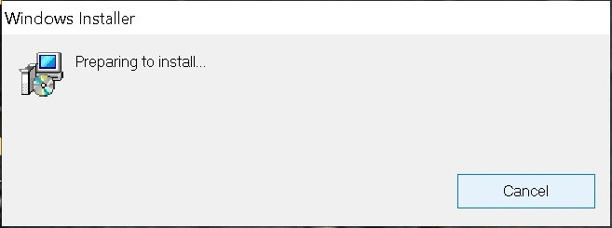
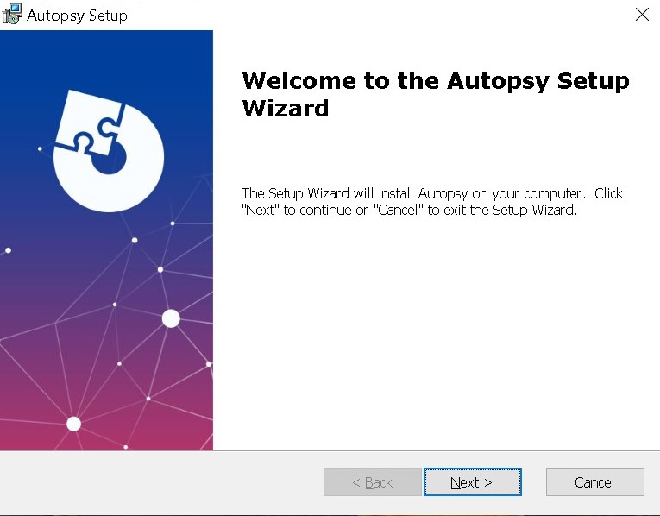

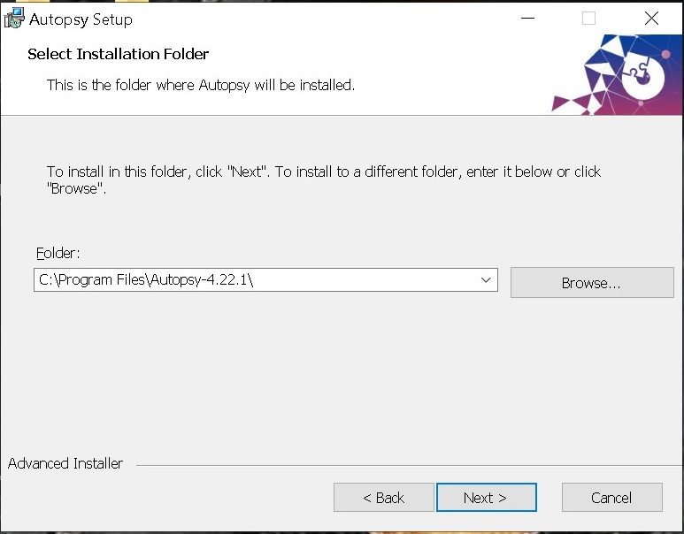

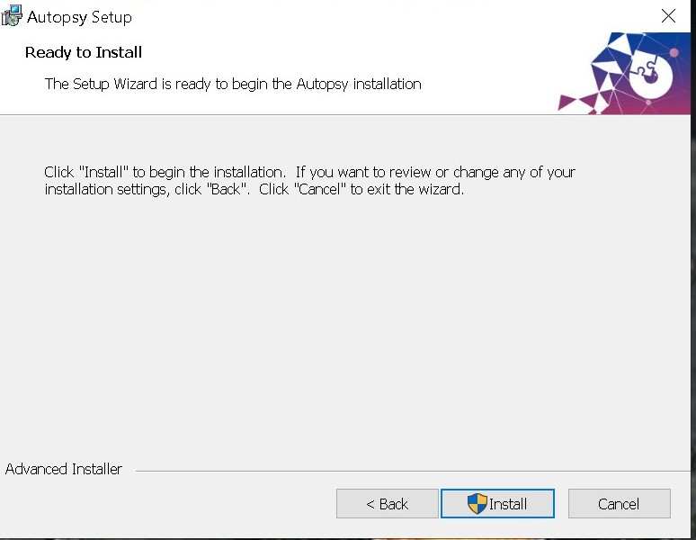

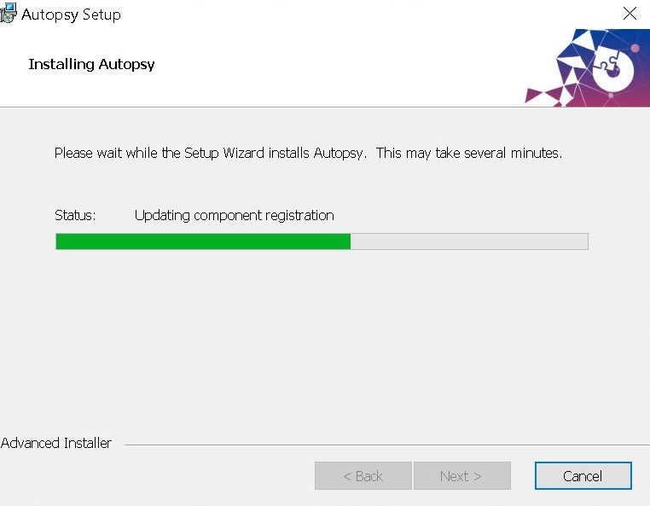
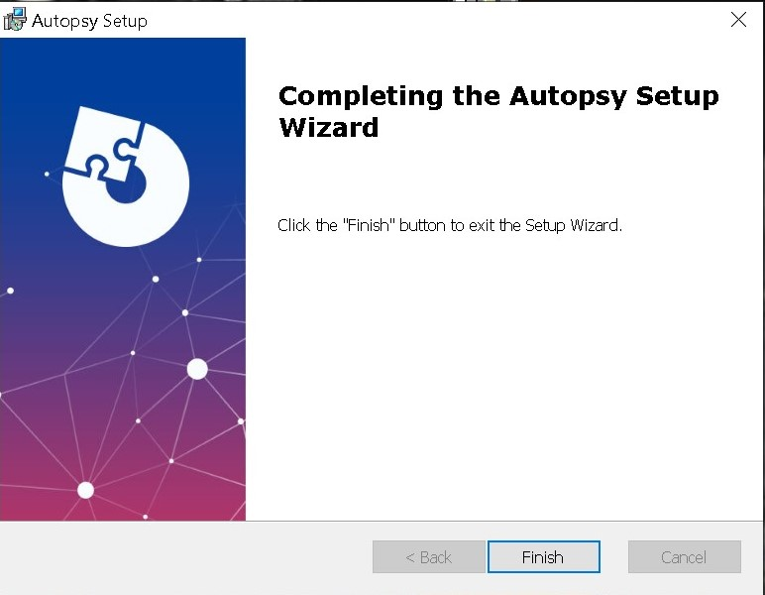

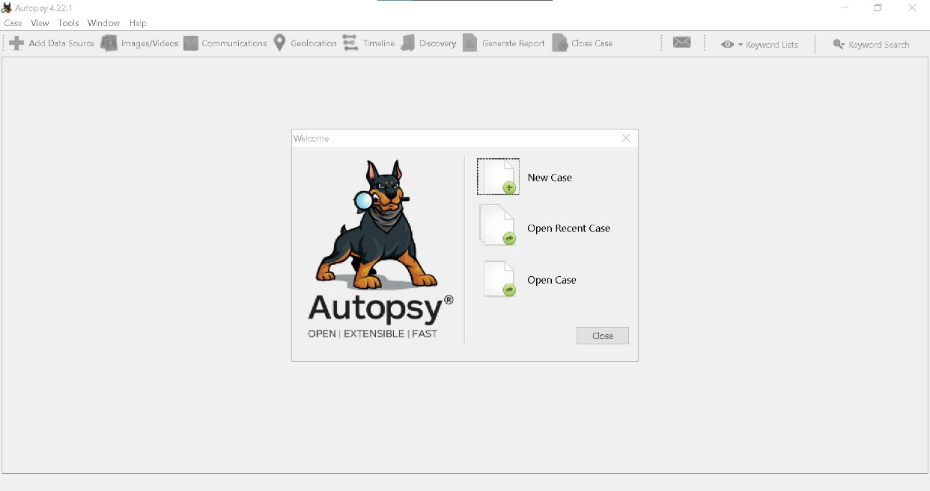

Task 2: Case Creation and Evidence Loading
Creating a case
1. Open Autopsy, click “Create New Case”.
2. Enter case name, description (optional), and base directory.
3. Click “Finish” to create the case.

A forensic image is a bit‑for‑bit copy of a storage device, capturing all data including slack space, unallocated space, and deleted files. It preserves the original data integrity via hash verification.
Explanation
The forensic image nps-2009-canon2-gen1.E01 was loaded as a data source. A forensic image is a bit‑for‑bit copy of a storage device, capturing all data including slack space, unallocated space, and deleted files. Hash verification preserved original data integrity.
Status: Case creation and evidence loading completed successfully.

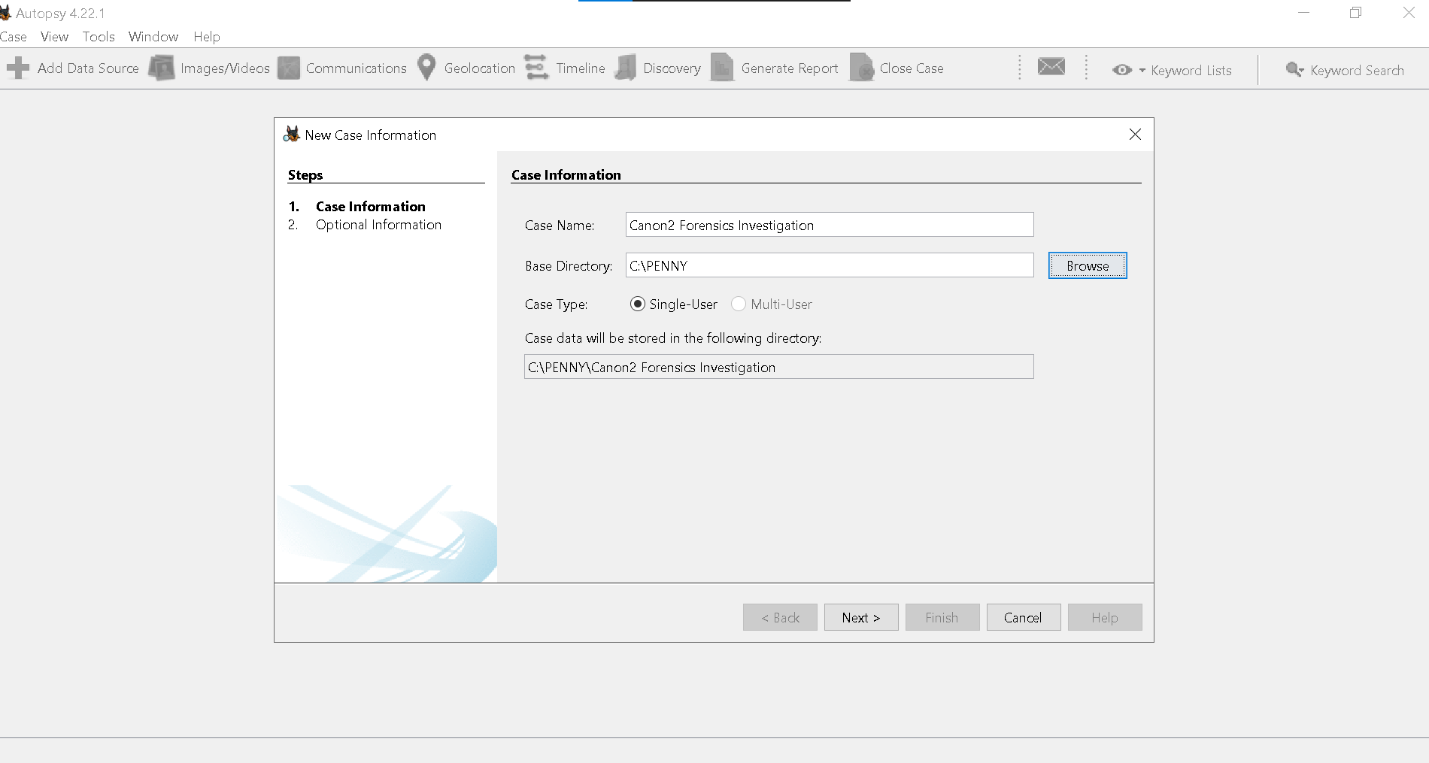

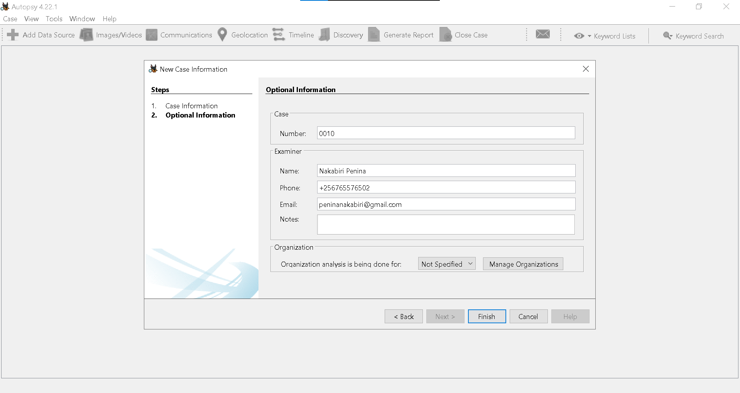

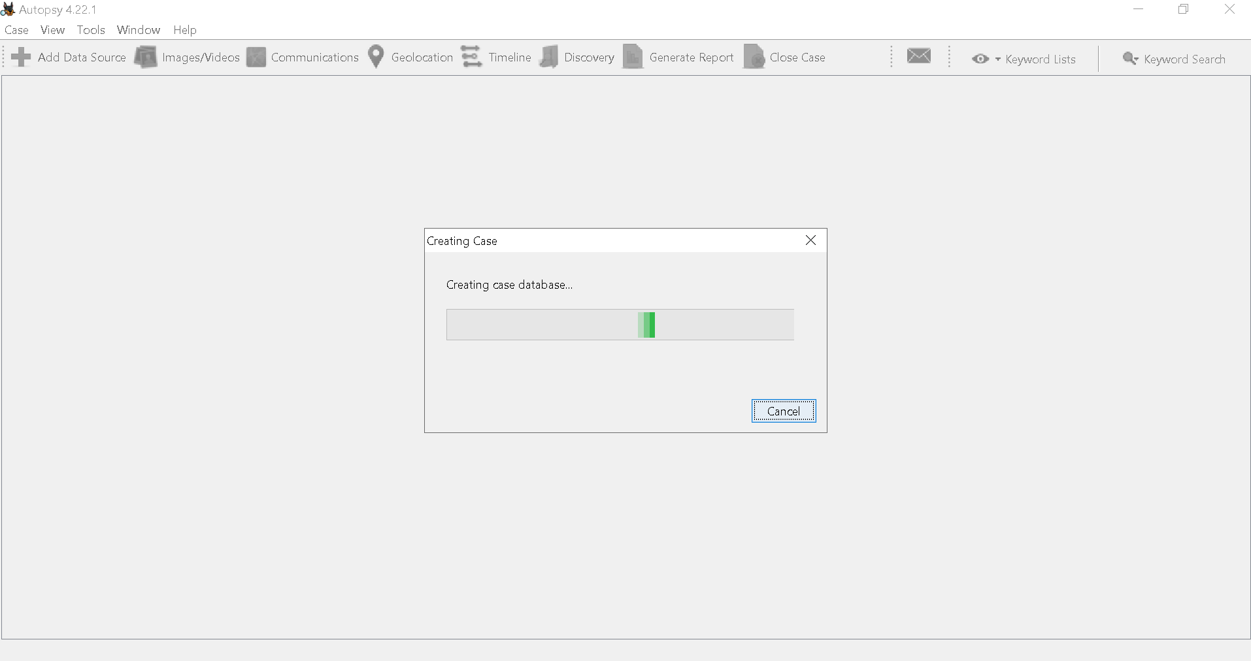

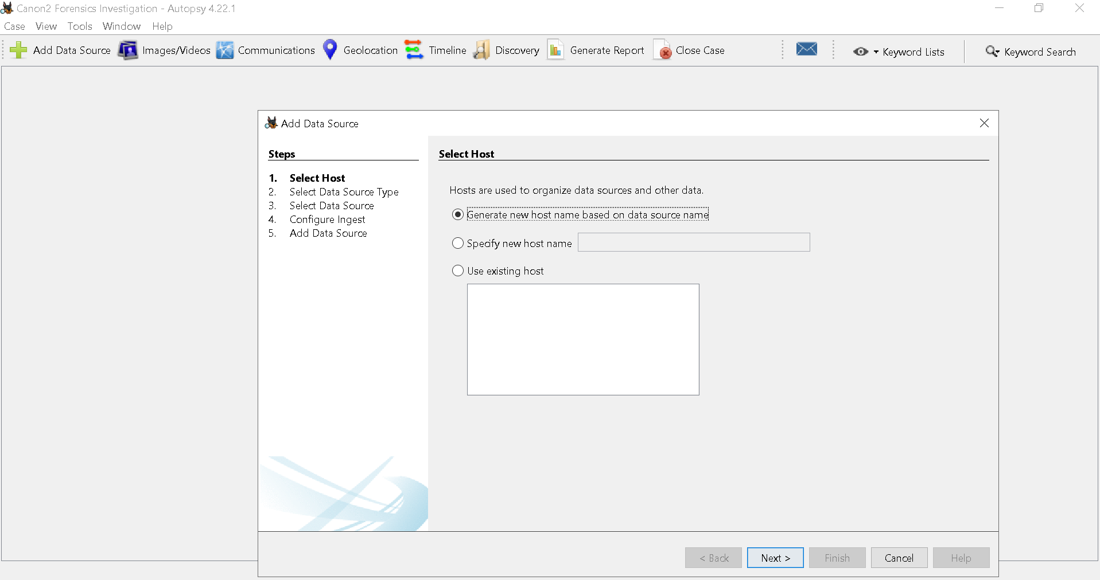

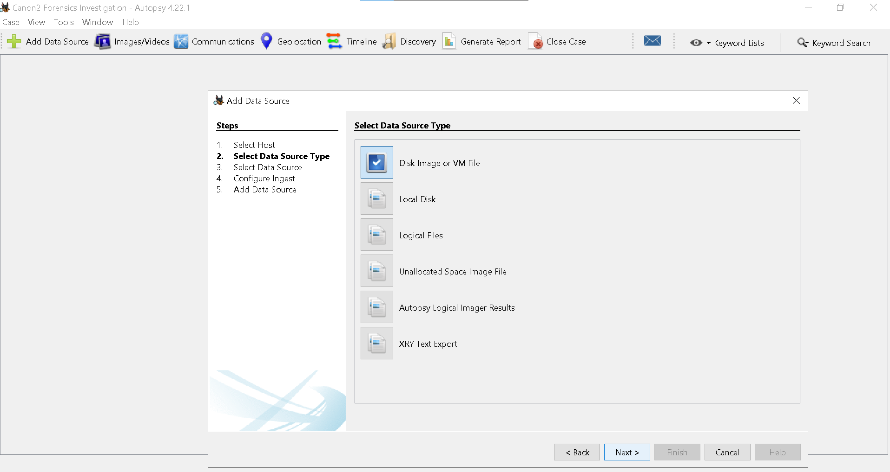

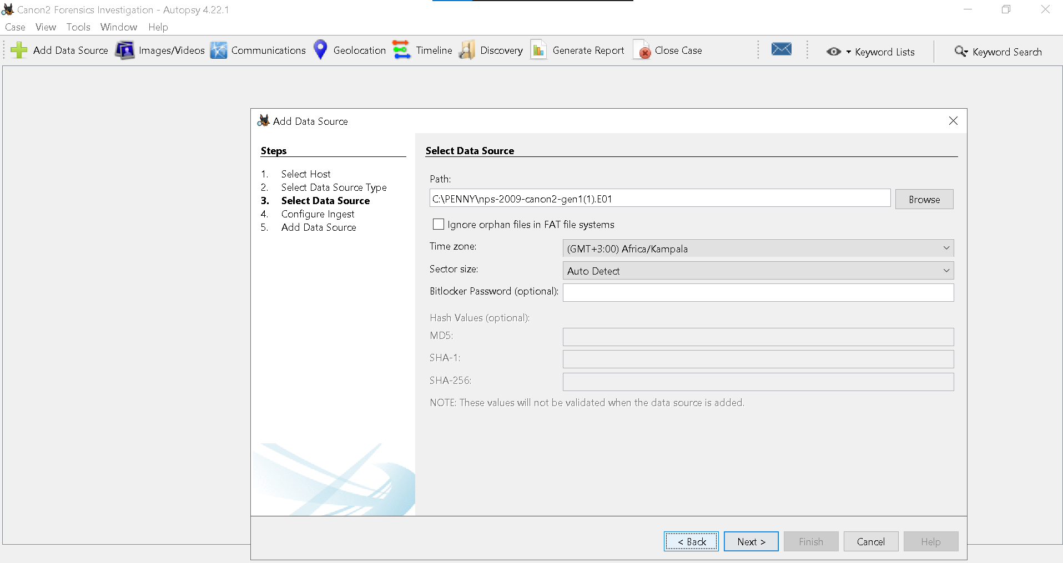

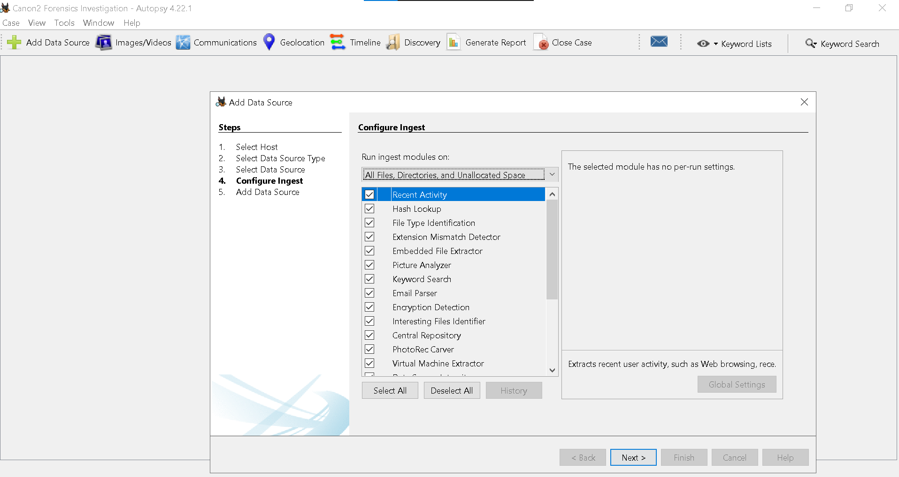

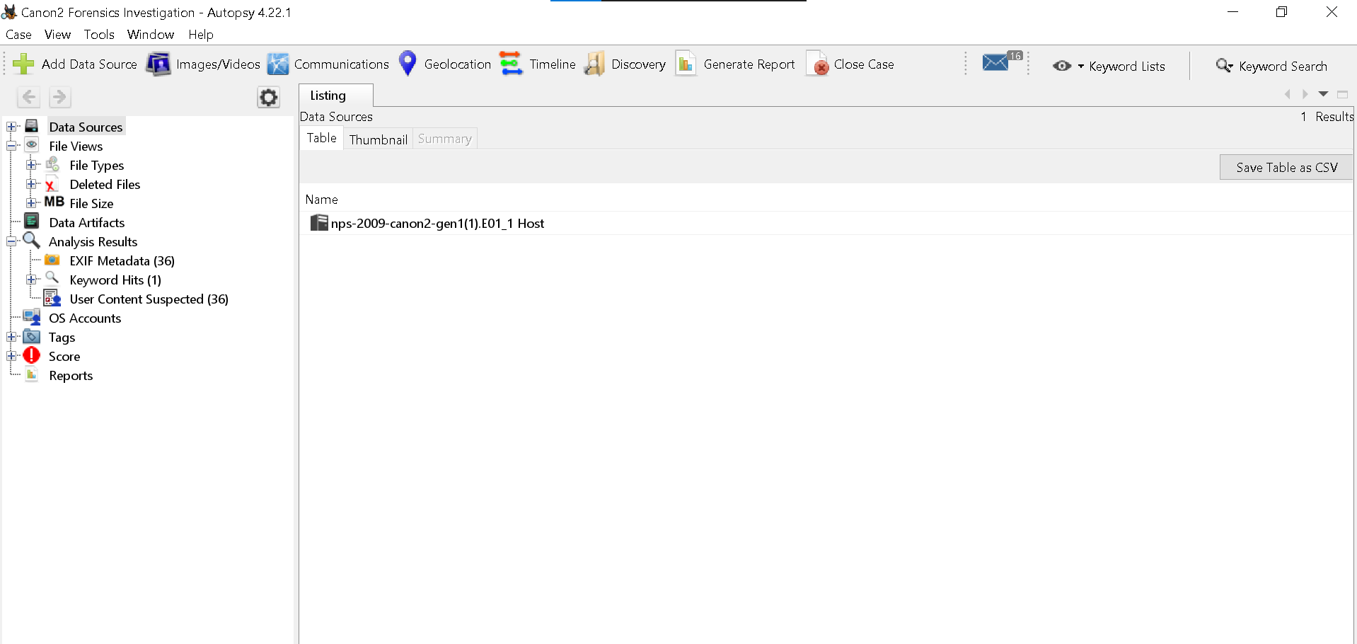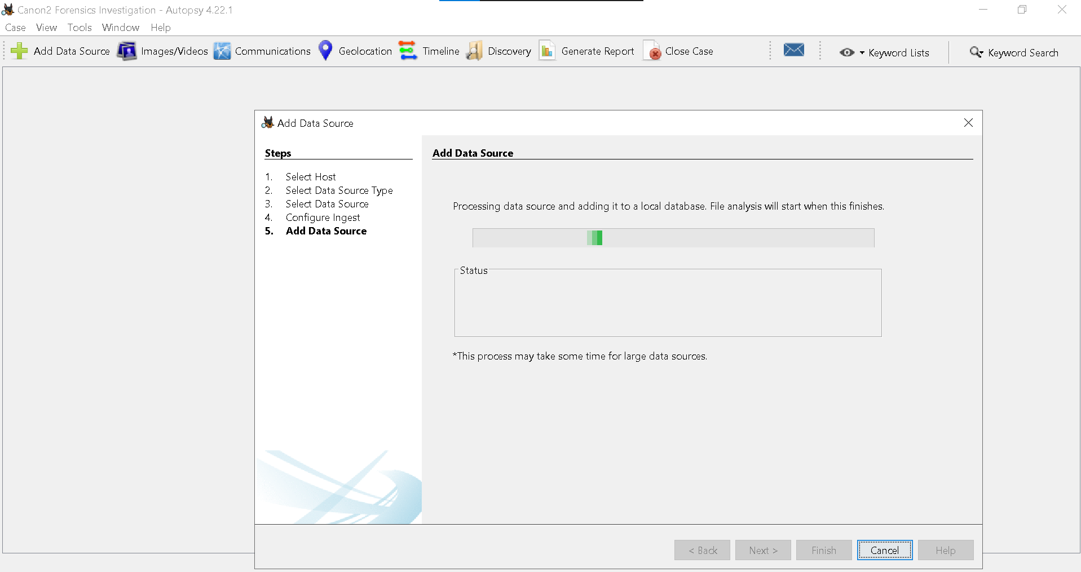

Task 3: File System Analysis
Analyzing file structures
After ingestion, Autopsy displays a directory tree (under “File System” or “Data Sources”). Navigate through folders to examine file types, metadata, and timestamps.

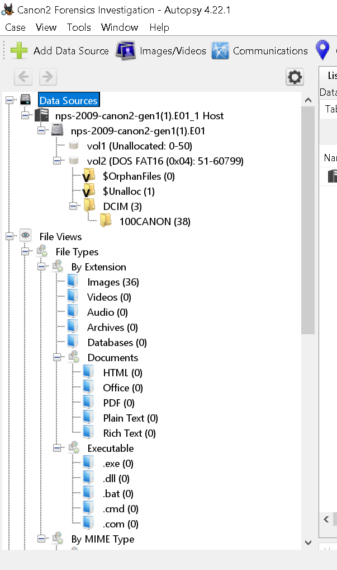

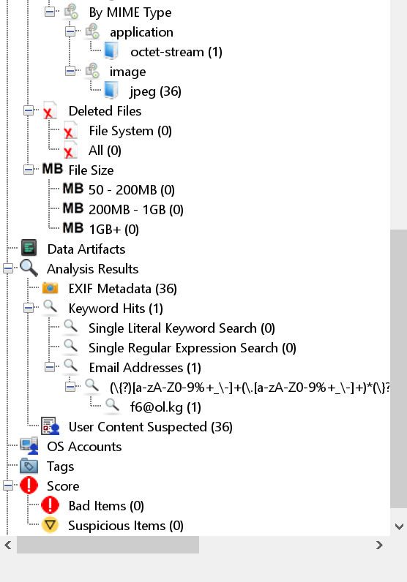

Suspicious files
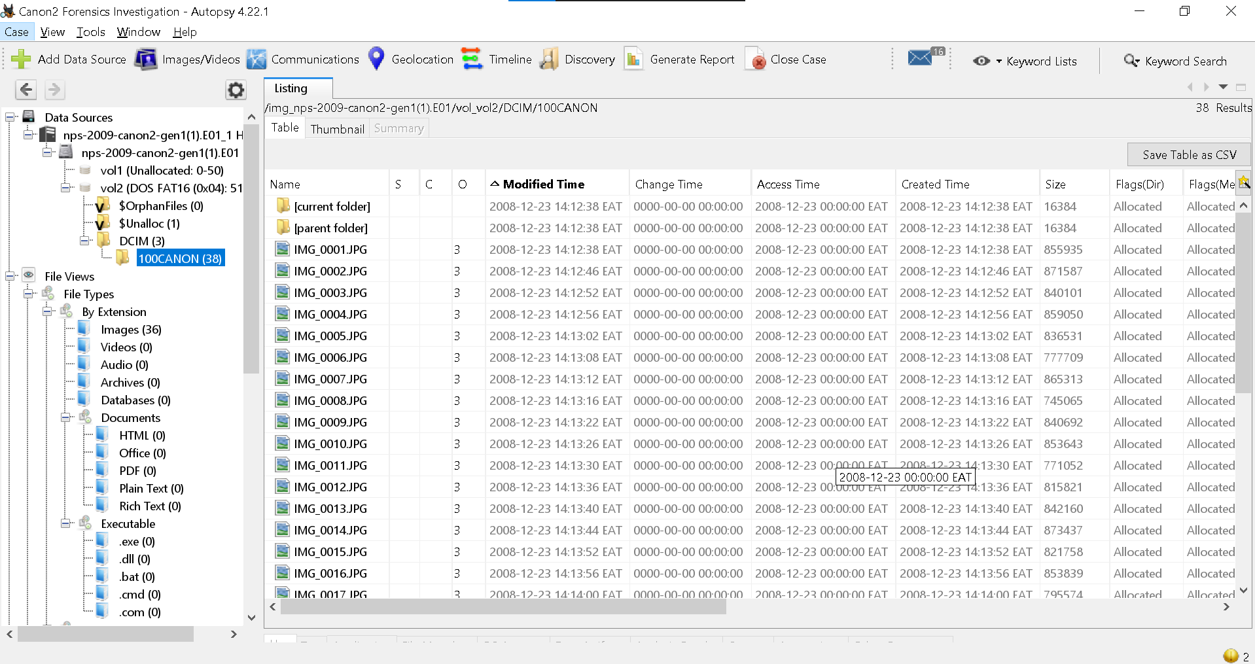

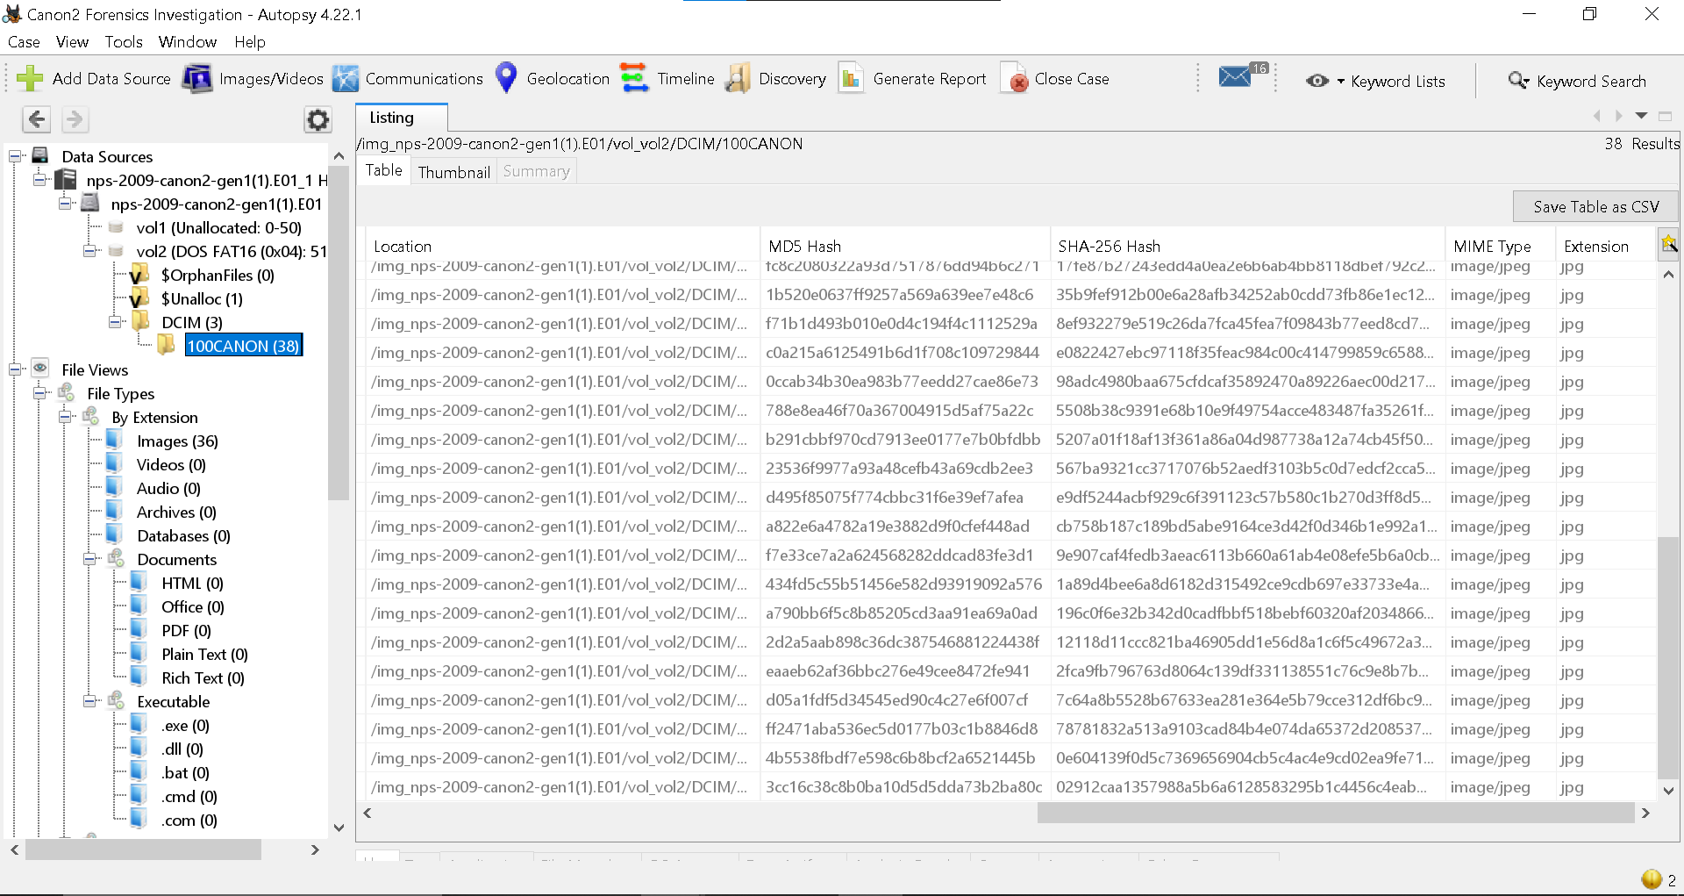

Accessed files
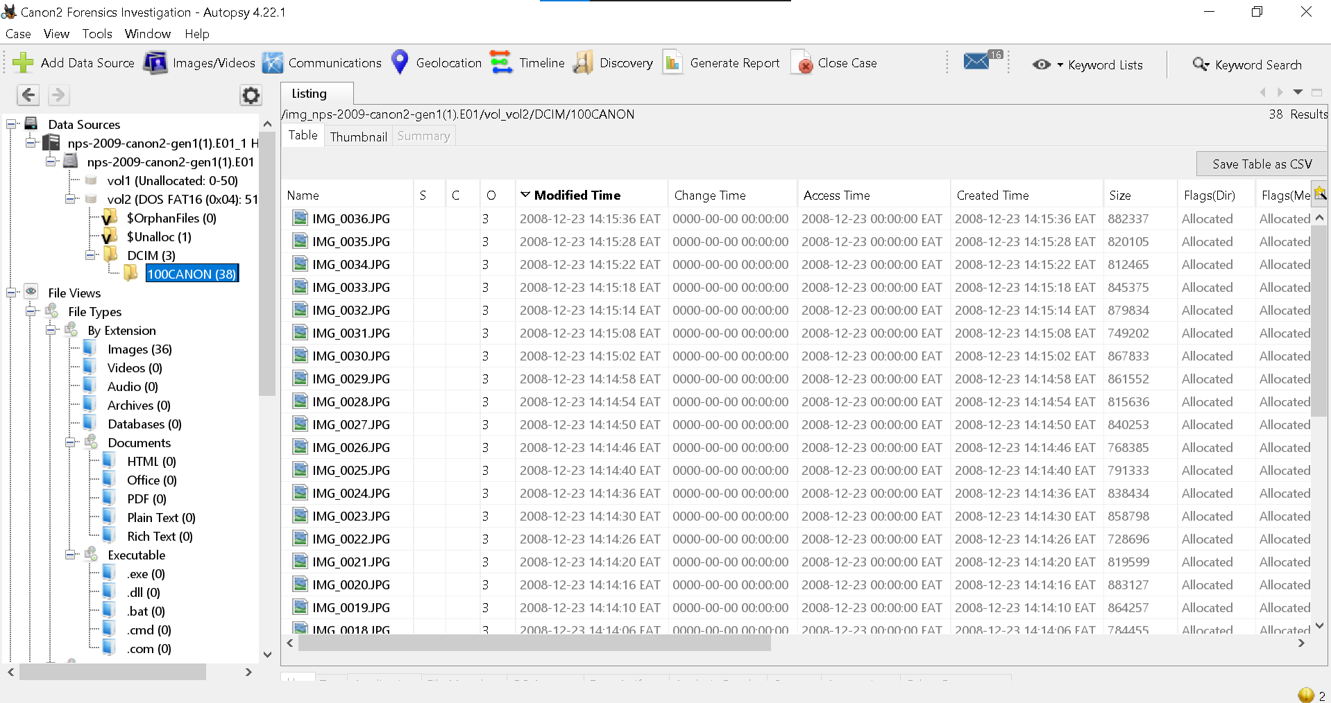

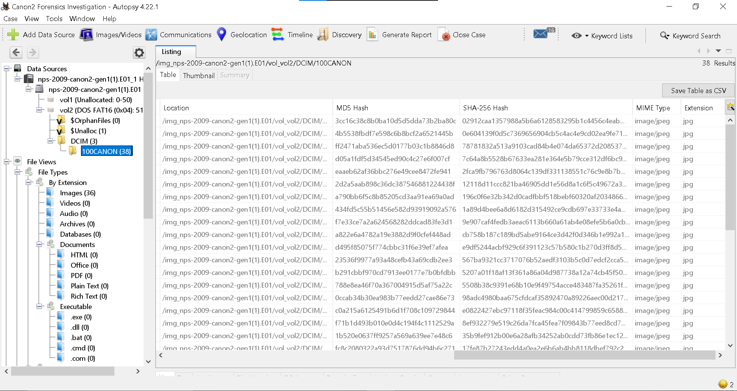

Task 4: Recovery of Deleted Files
$Unalloc (1) - One unallocated space region was found, containing potential recoverable
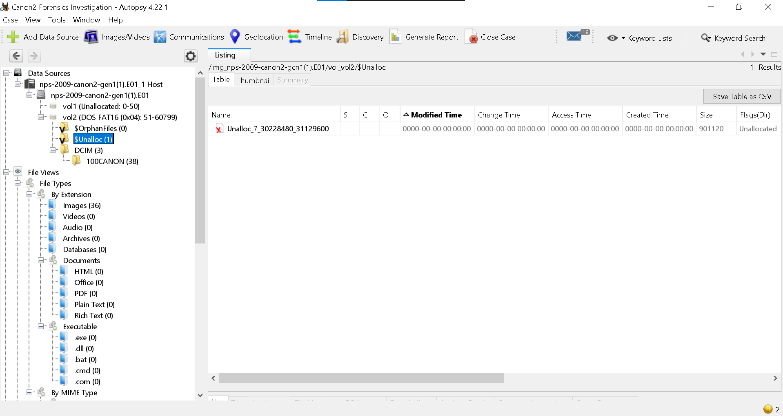
$Orphan files(0), 0 No orphan files (files without directory entries) were present.
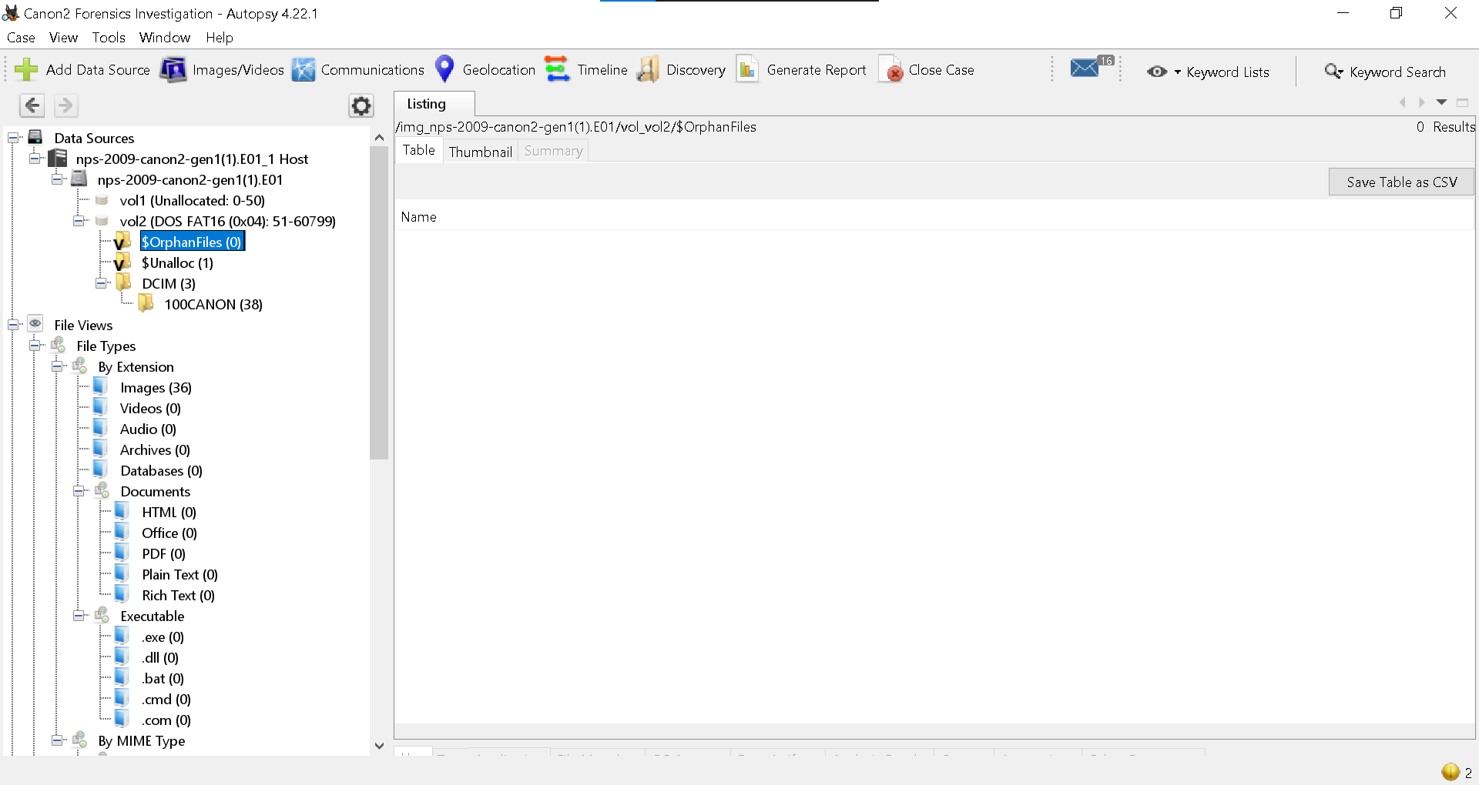

Recovered files - Deleted files were successfully extracted from unallocated space.
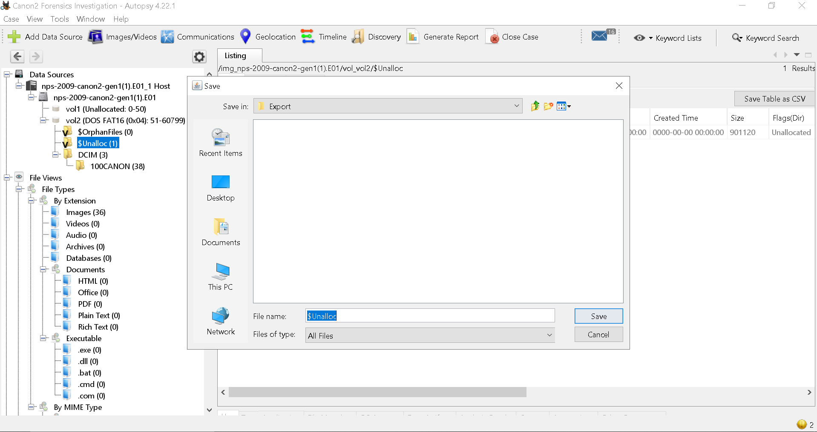

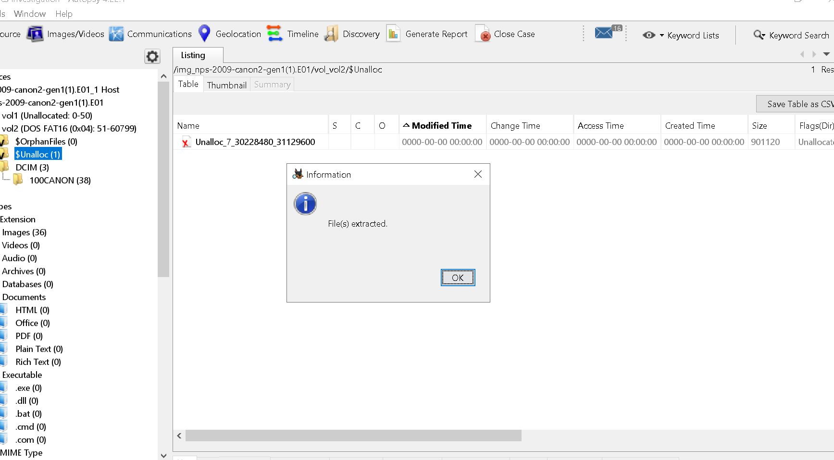

Relevance
- was evaluated for investigation integrity
Conclusion
- Deleted files were recoverable. Relevance checking confirmed that some recovered items may be pertinent to the case.

Task 5: Web Activity Analysis
The forensics image nps-2009-canon2-gen1.E01 is a digital camera memory card, not a computer hard drive. Therefore, no browser history present, no cookies present, no download records present
This is expected behaviour for this evidence type and does not indicate an error in analysis methodology.

Task 6: Keyword Search and Filtering
Keyword Password
Result: No results found
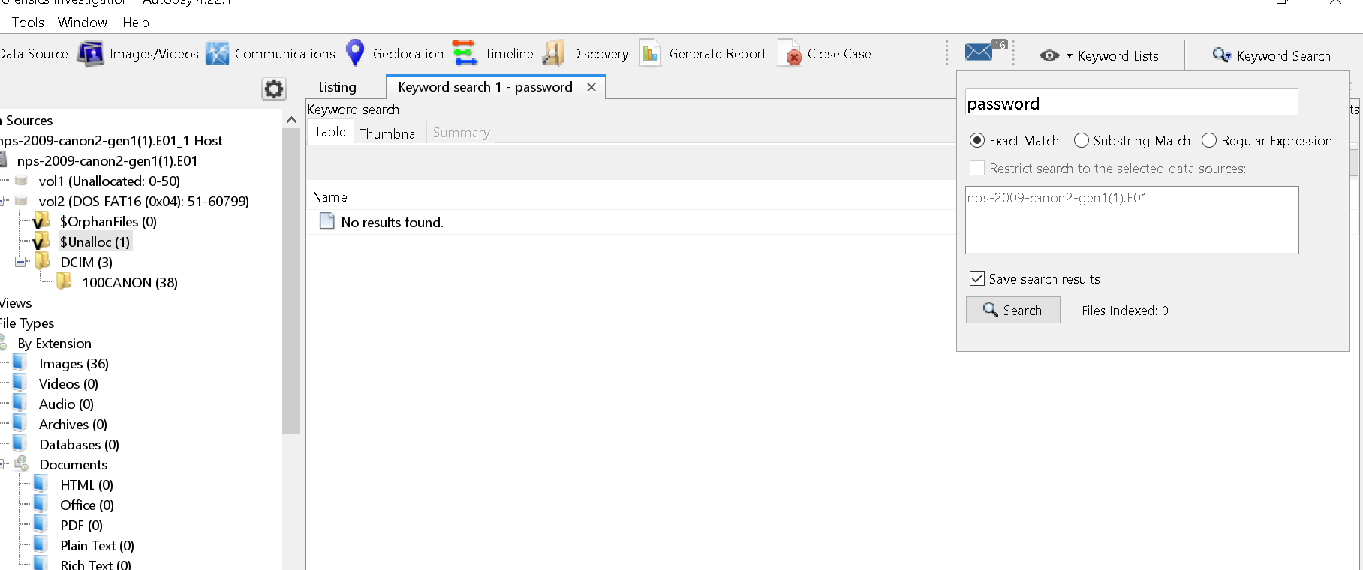

Keyword confidential
Result: No results found
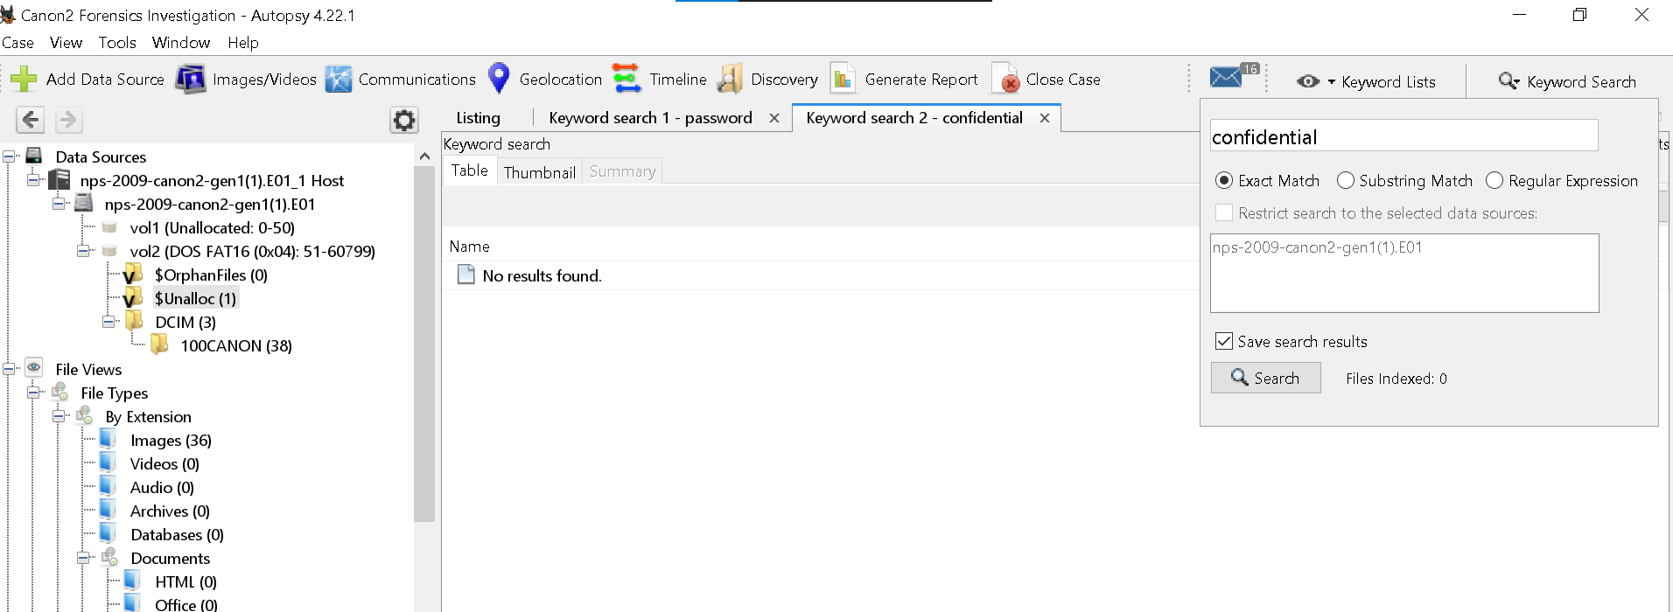

Analysis:
- Absence of these text strings does not reduce the evidentiary value of the image. Camera memory cards typically store binary image files (JPEG, RAW) and metadata, not plain text documents.

Task 7: Timeline Analysis
Counts view - Event frequency over time (bar chart) No unusual spikes detected
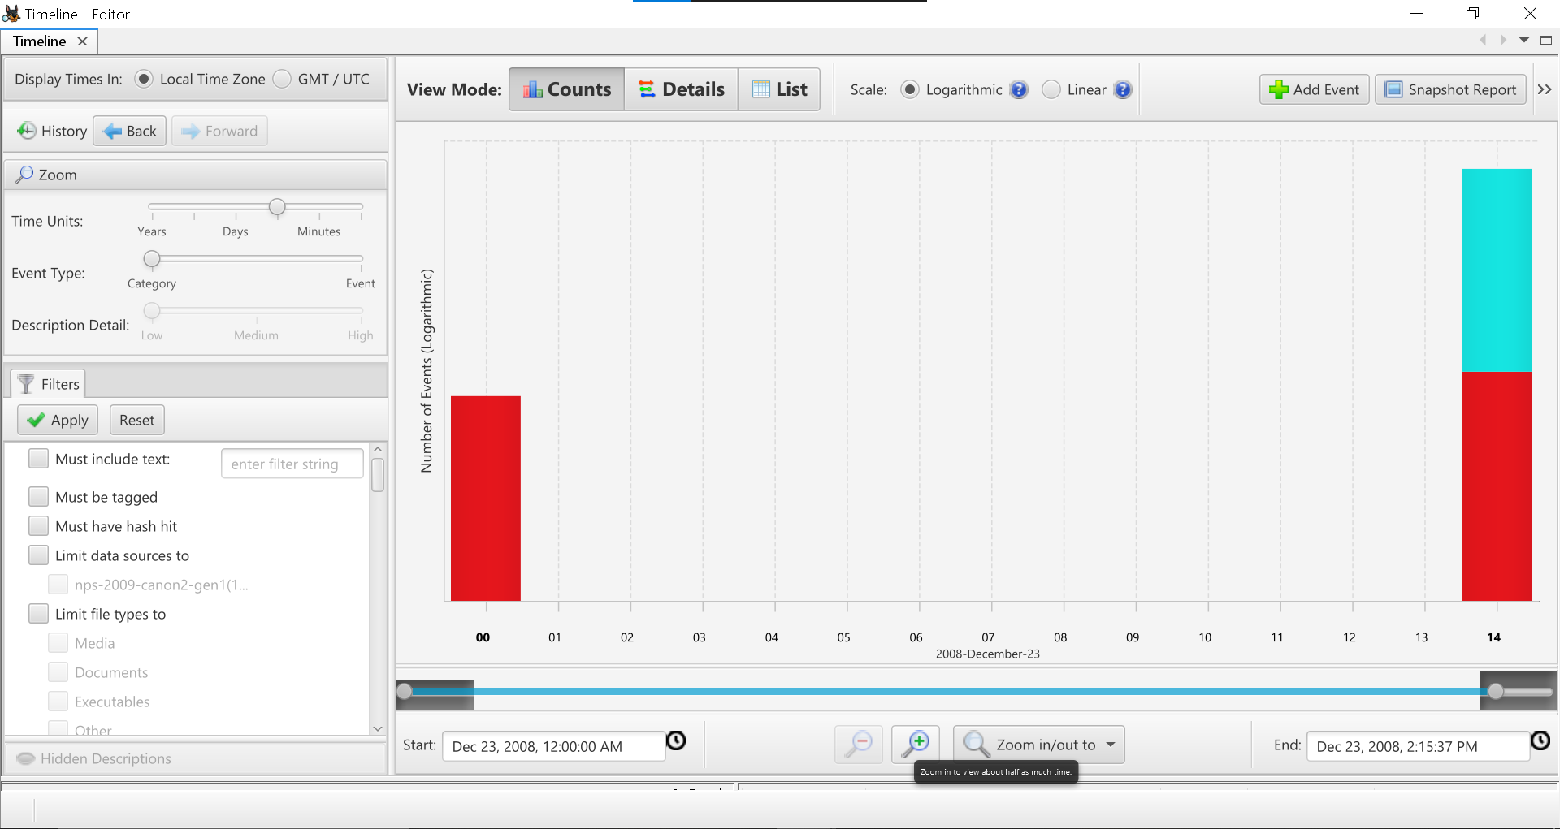

Details view - Each event with timestamp, file path, and type Useful for reconstructing photo capture/deletion sequences
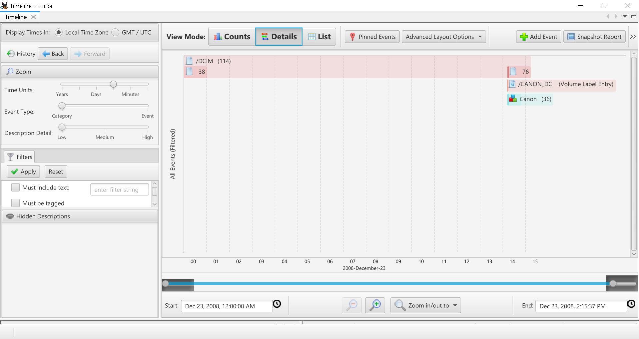

List view - Chronological list of all events Allows linear review of activity from formatting to last use
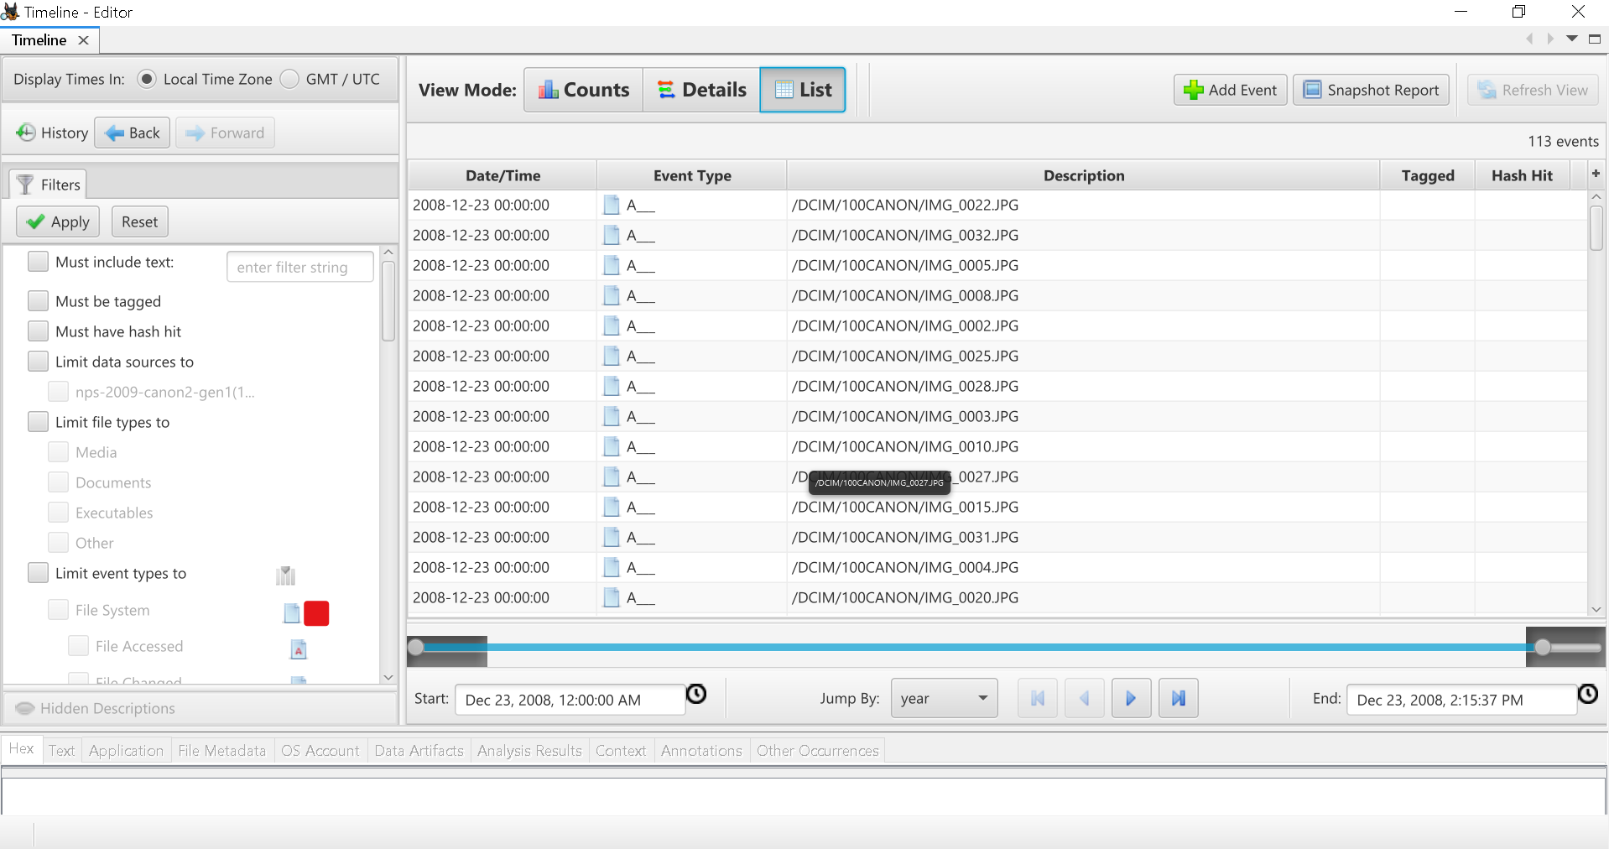

5.SUMMARY OF FINDINGS
- Task Outcome
- Case creation & evidence loading Successful
- File system analysis Directory tree parsed; files examined
- Deleted file recovery $Unalloc (1), orphan files (0), files recovered and relevance assessed
- Web activity analysis No browser artifacts (expected for camera card)
- Keyword search No matches for "password" or "confidential"
- Timeline analysis Three views generated; no anomalies

6. CONCLUSION
The forensic examination of nps-2009-canon2-gen1.E01 was completed without errors. All Autopsy features were exercised according to standard procedures. The evidence type (digital camera memory card) correctly explains the absence of web artifacts and text-based keyword matches. Deleted file recovery and timeline analysis remain the most valuable sources of potential evidence for this image.

